VM B(With OSSEC): 10.0.2.4

Screenshot showing that OSSEC was successfully installed and able to be started

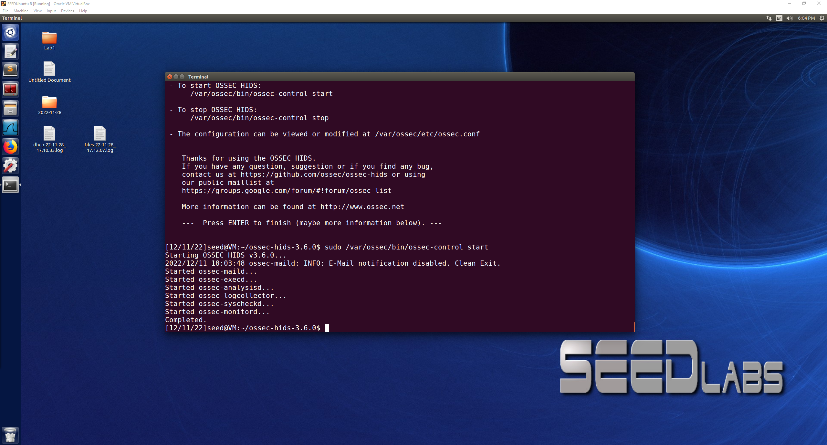

Severity Levels changed to 3 and 9

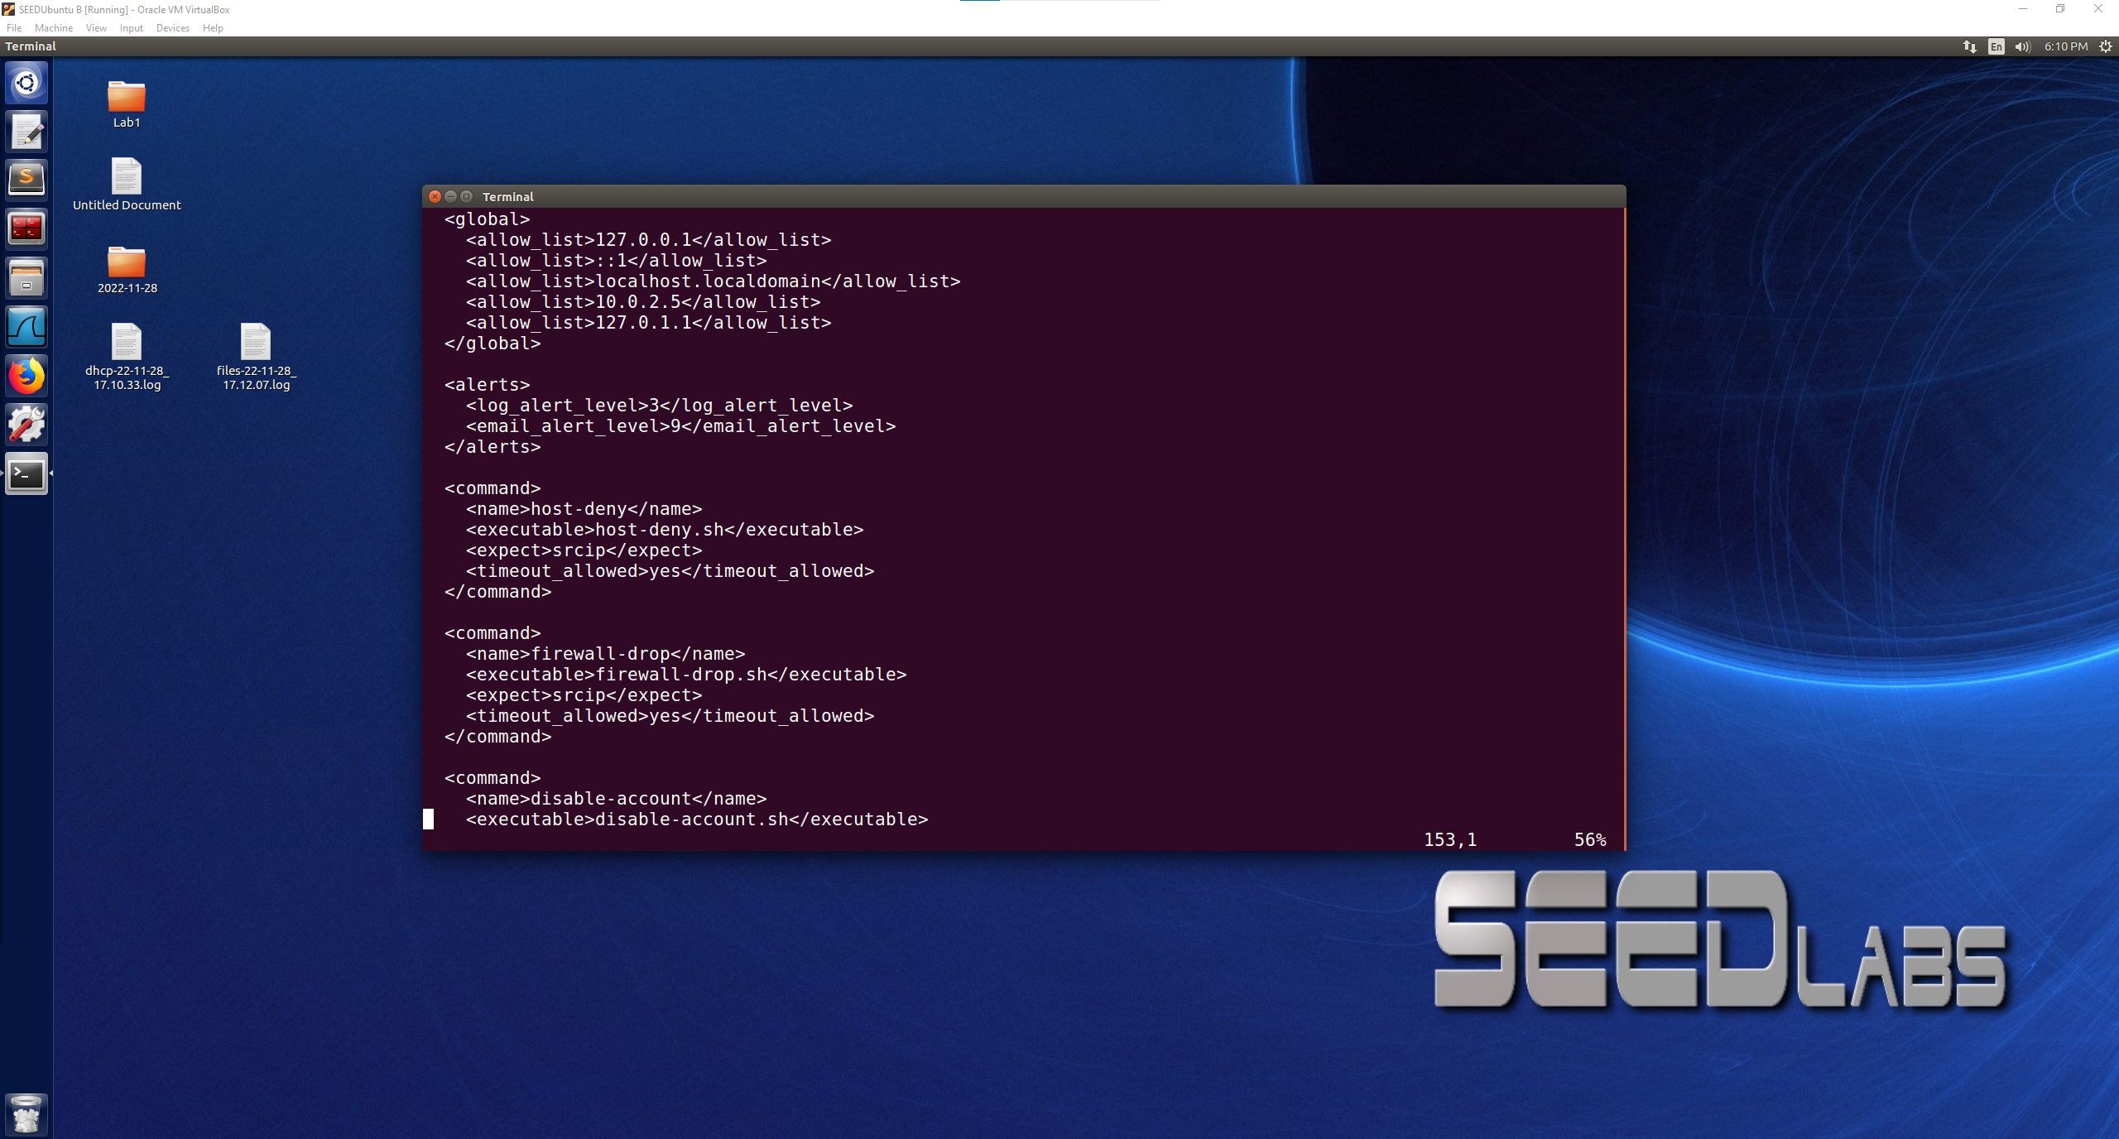

Password guessing attack, 10 attempts through telnet

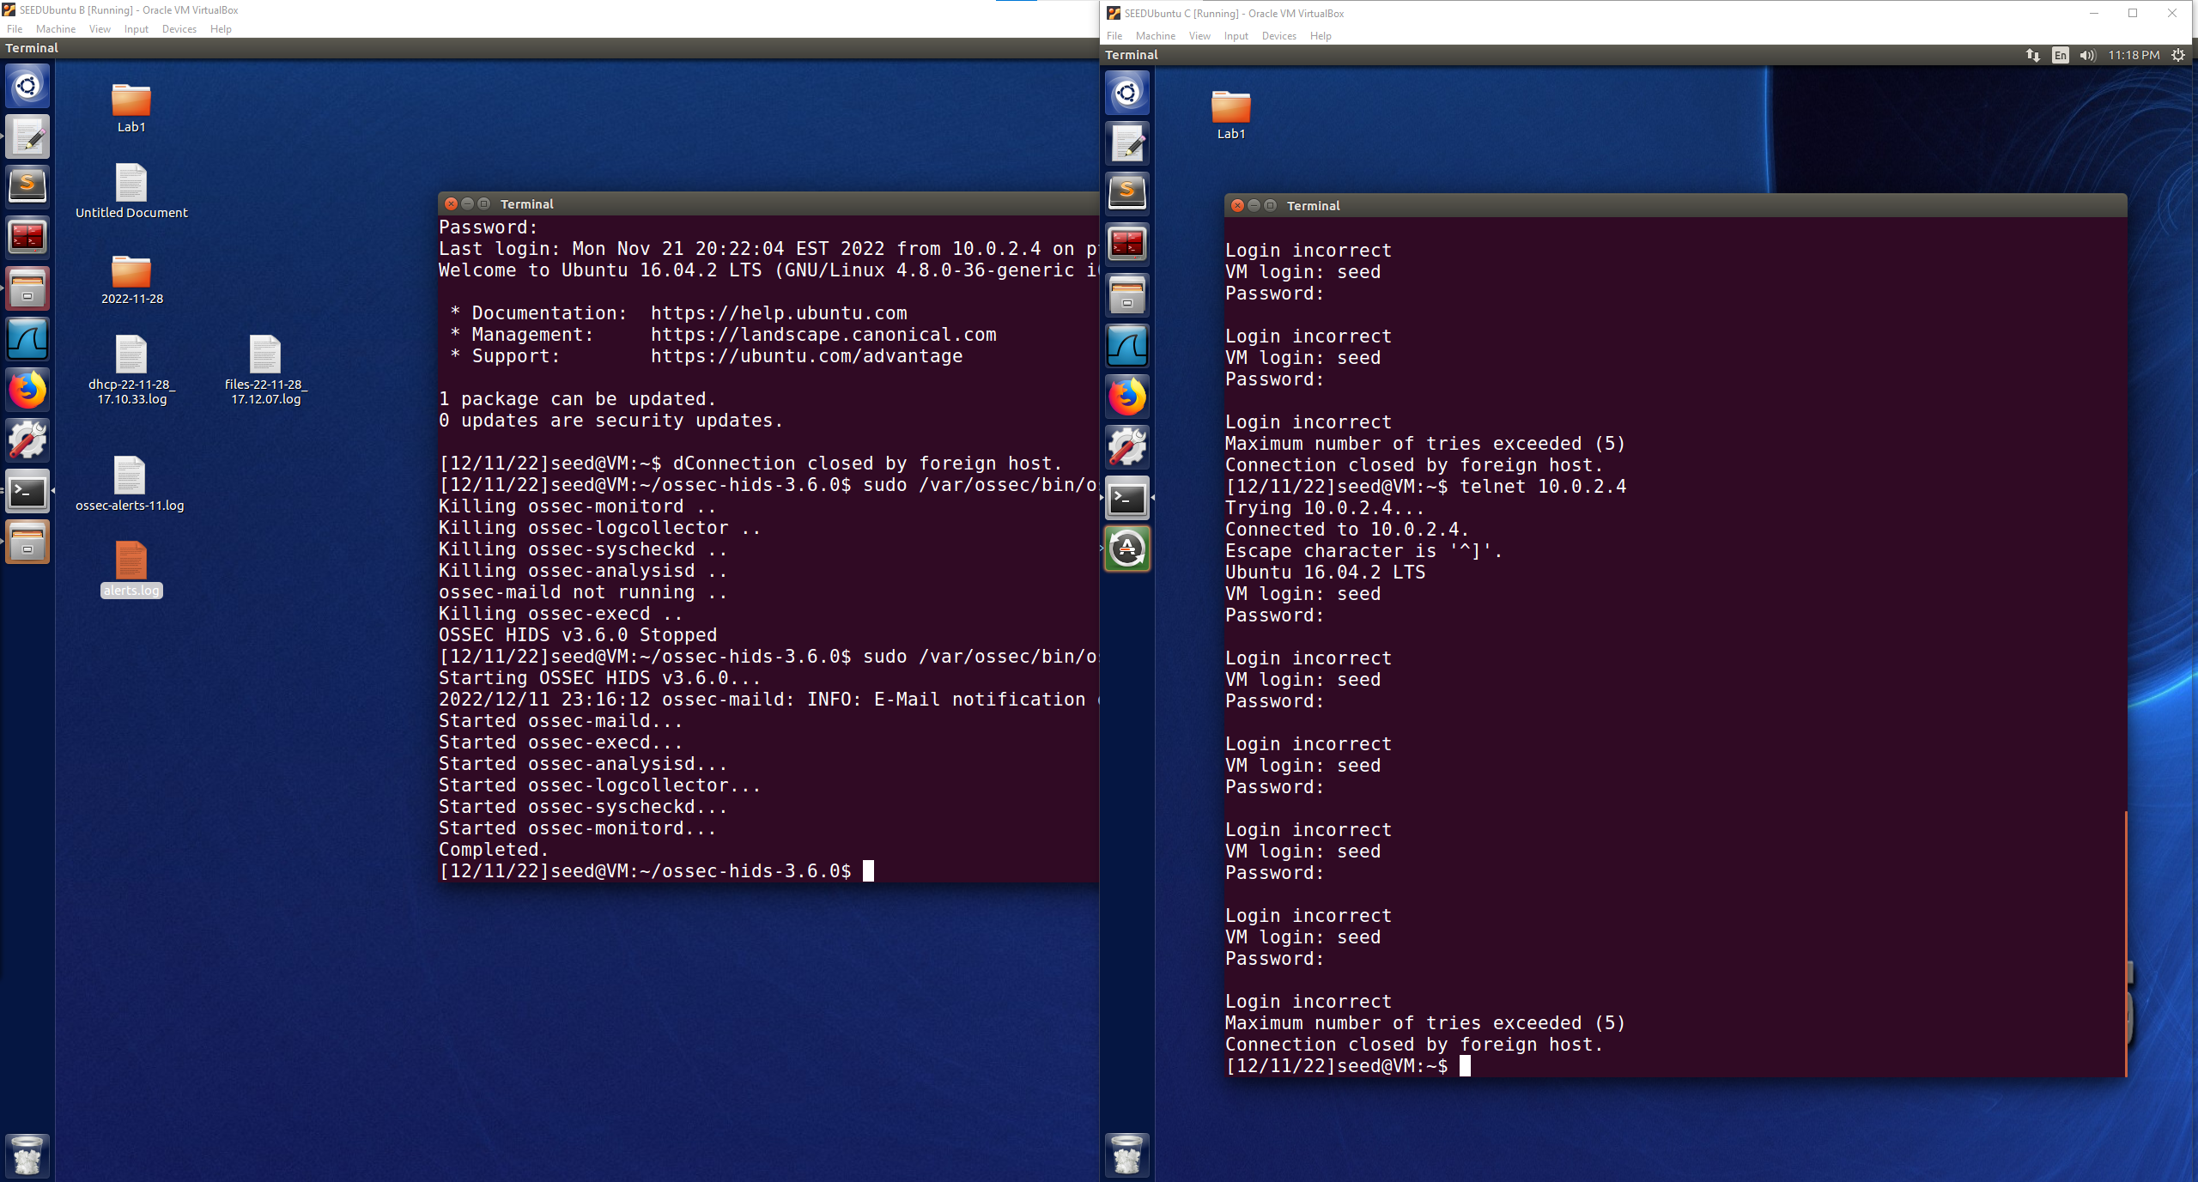

Browsing a few https

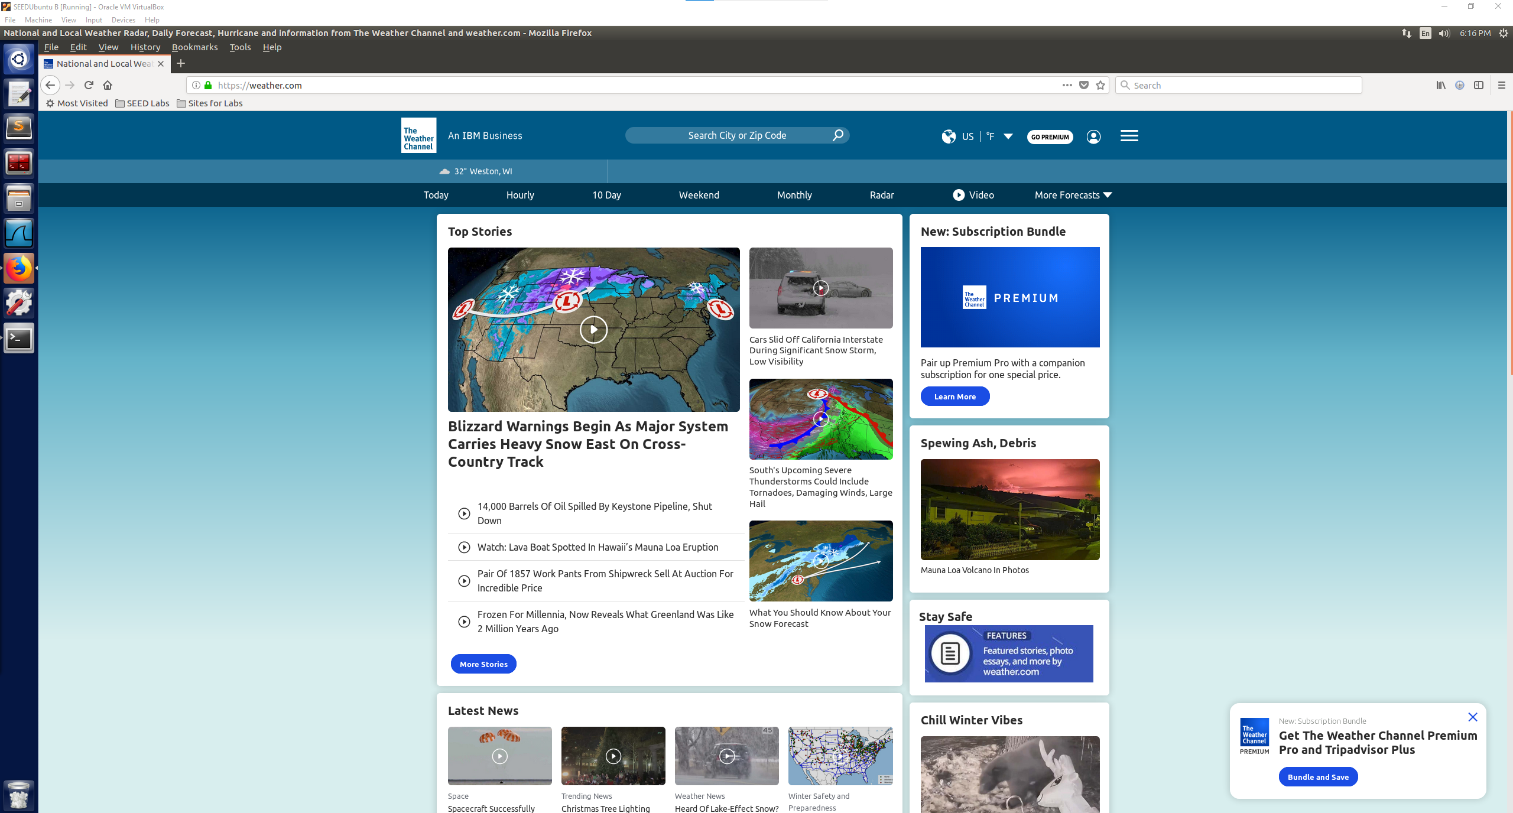

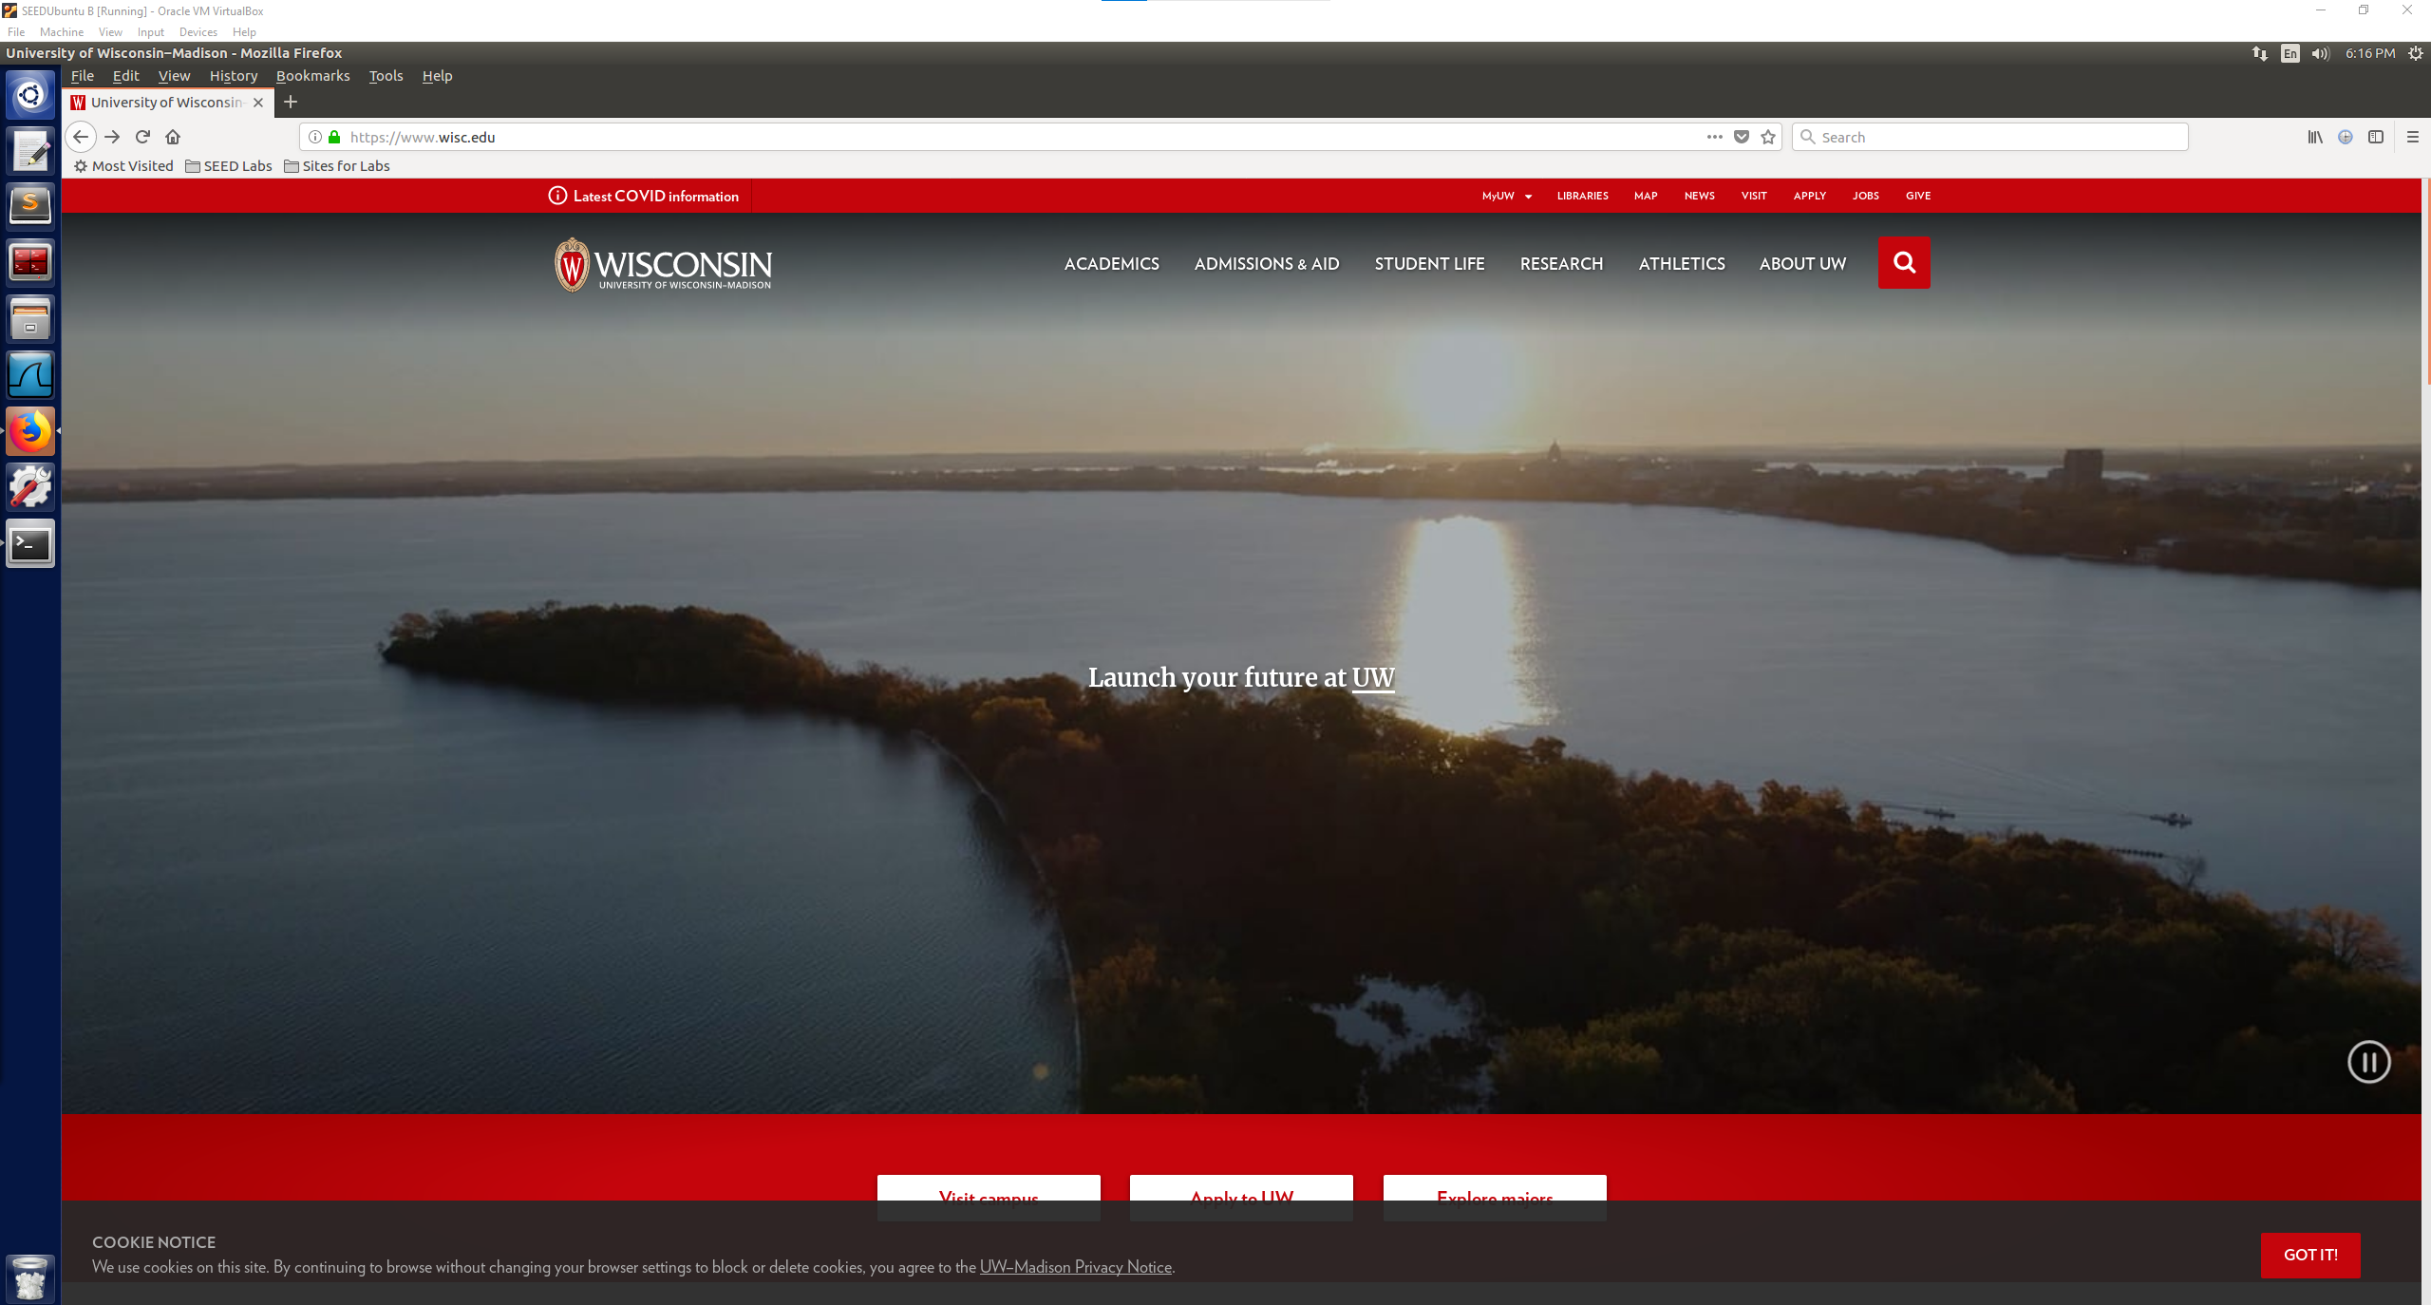



Browsing some http sites

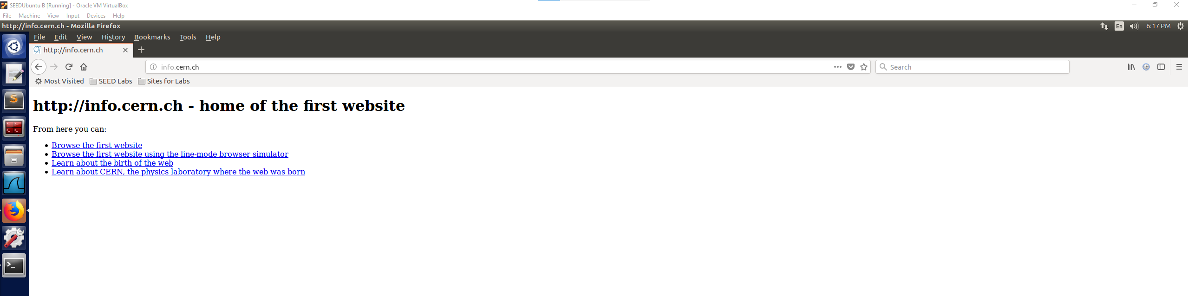

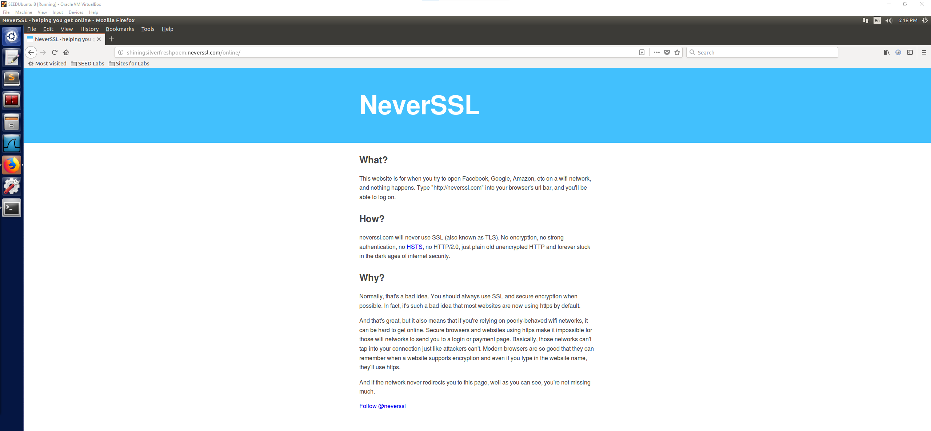

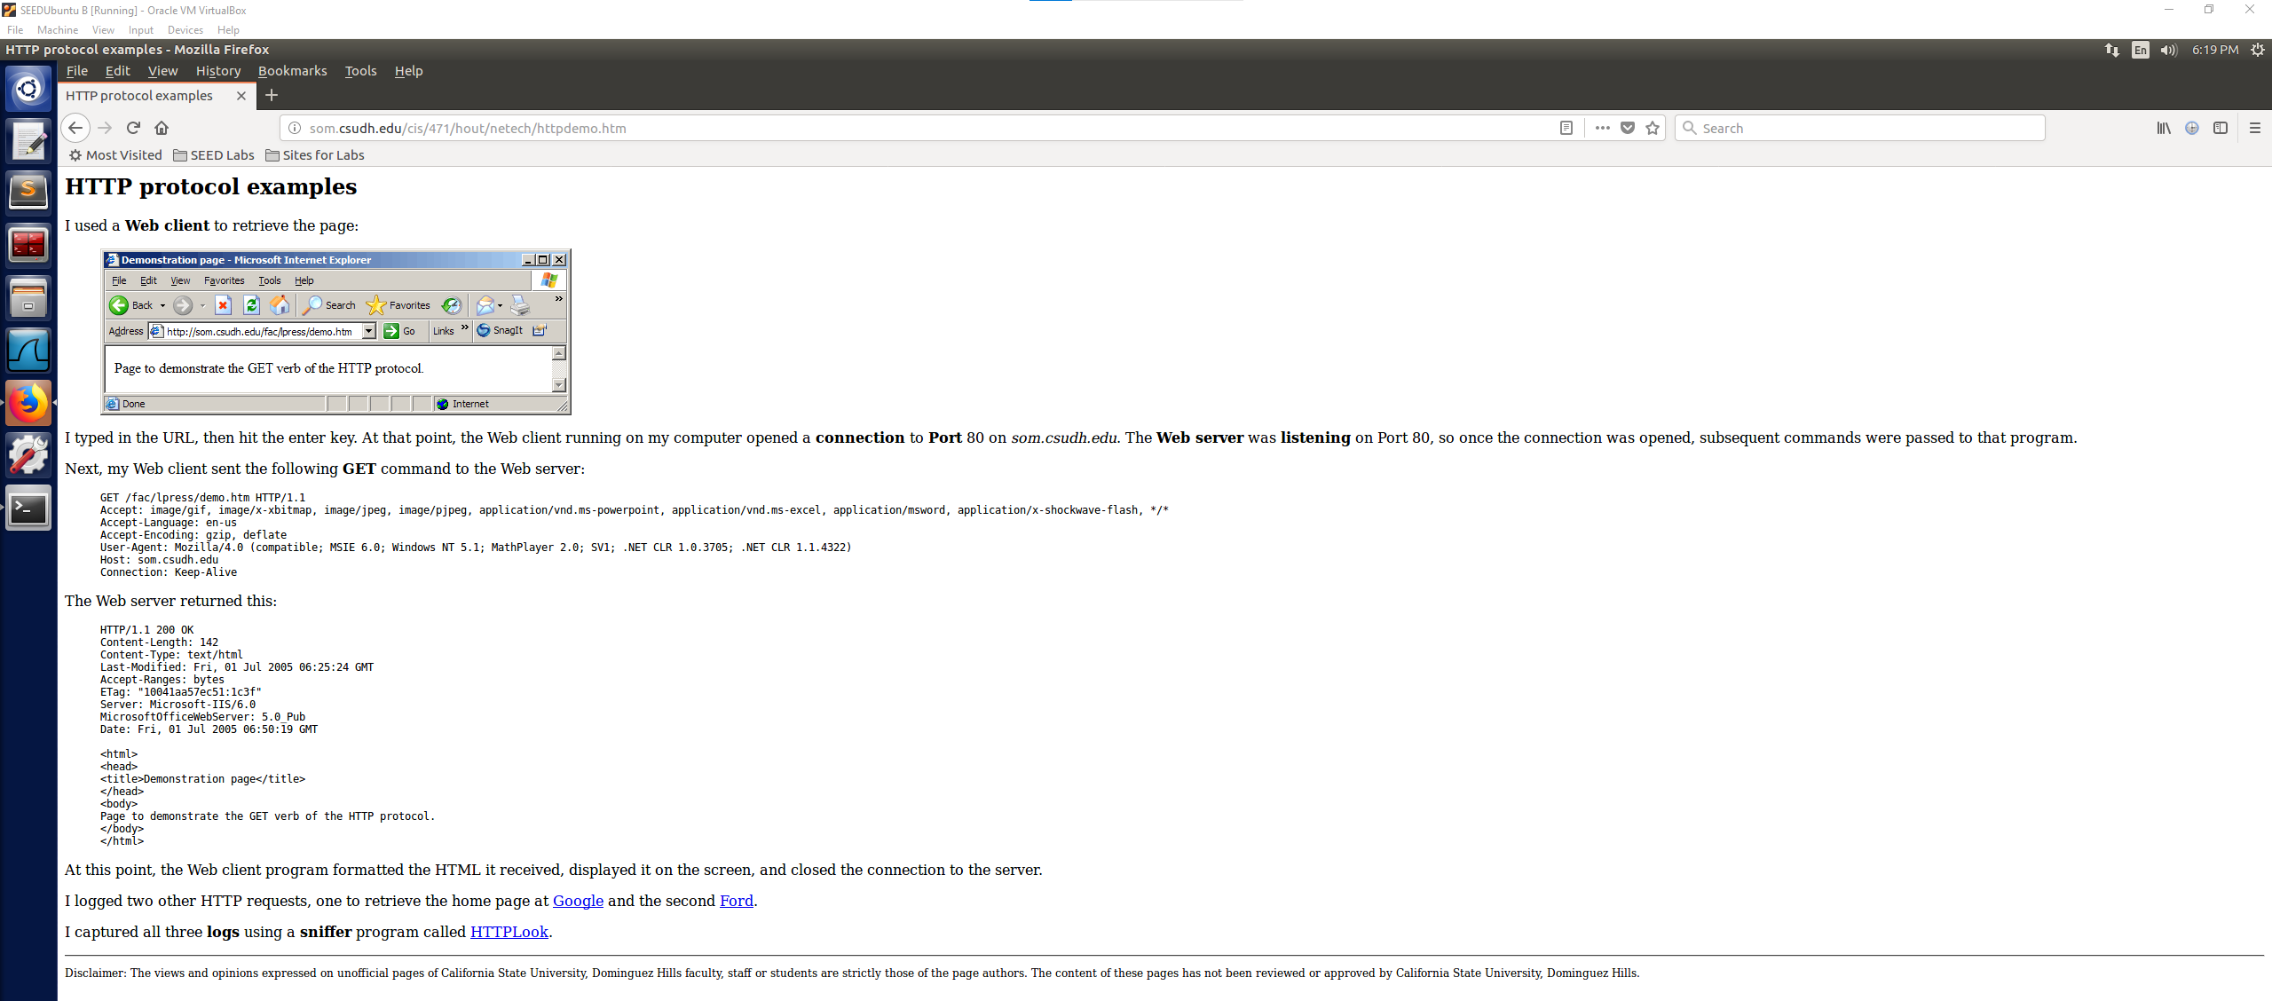

**Attack 1:** nmap port scanning for open ports on OSSEC VM 10.0.2.4

nmap 10.0.2.4 -v

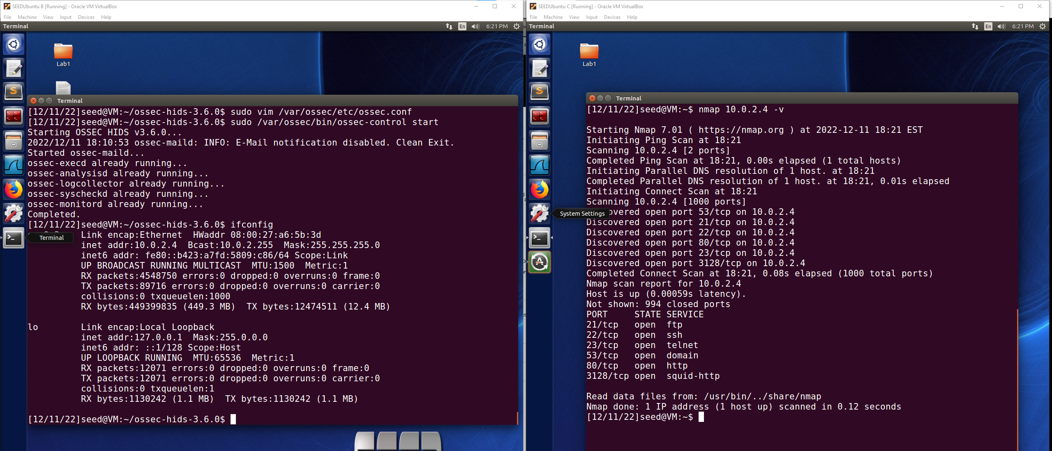

**Attack 2:** SYN Flood Attack on OSSEC VM 10.0.2.4

sudo netwox 76 -i 10.0.2.4 -p 80 -s raw

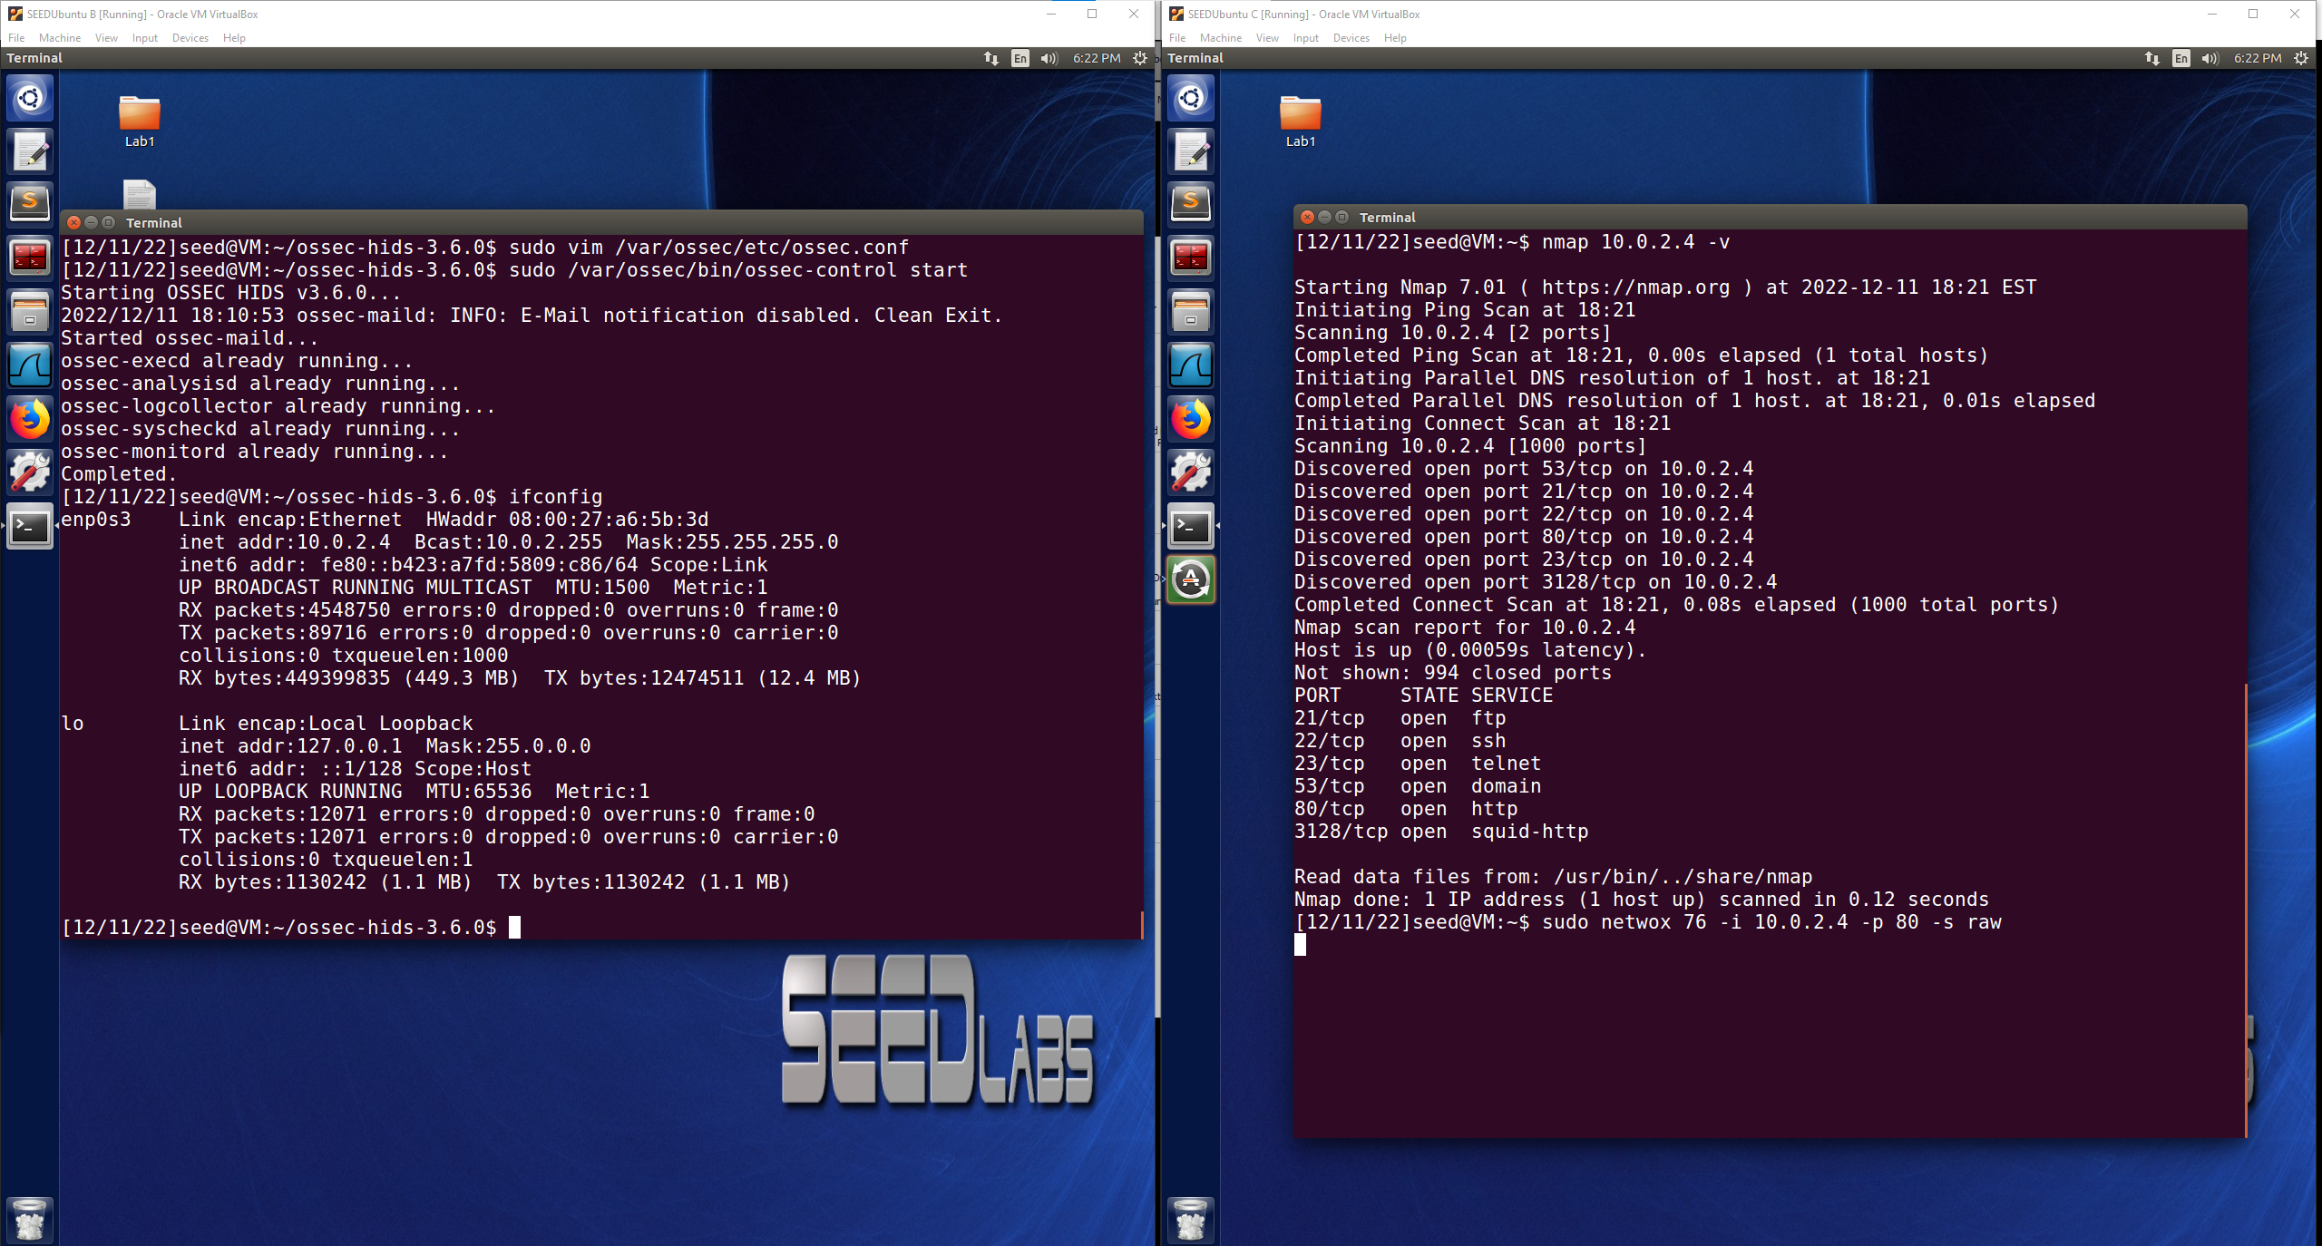

**Attack 3:** TCP reset attack on OSSEC VM 10.0.2.4 when telnet to 10.0.2.7

sudo netwox 78 -d enp0s3 -f “src host 10.0.2.7”

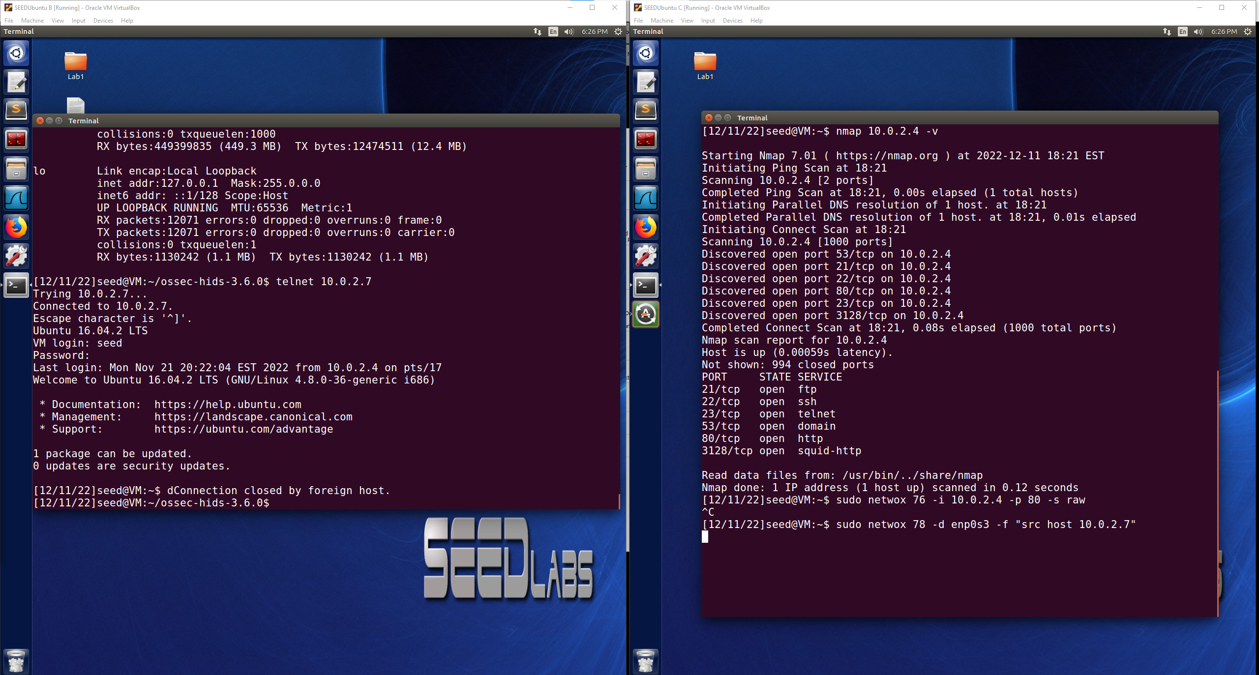

After stopping OSSEC and pulling up the alerts.log I was able to see the alerts for the incorrect password attempts. In the image below one of the attempts is highlighted where the Rule 2501 alert was issued labeled as “User authentication failure”, it also lists information such as the user that was trying to be accessed and then the attempt number that it was. After 5 attempts the connection session was closed and then re-opened for another 5 attempts. There is also information provided about the source IP address that was trying to access the user. This is a good informational log of the password attempt amounts, to what user, and where they came from.

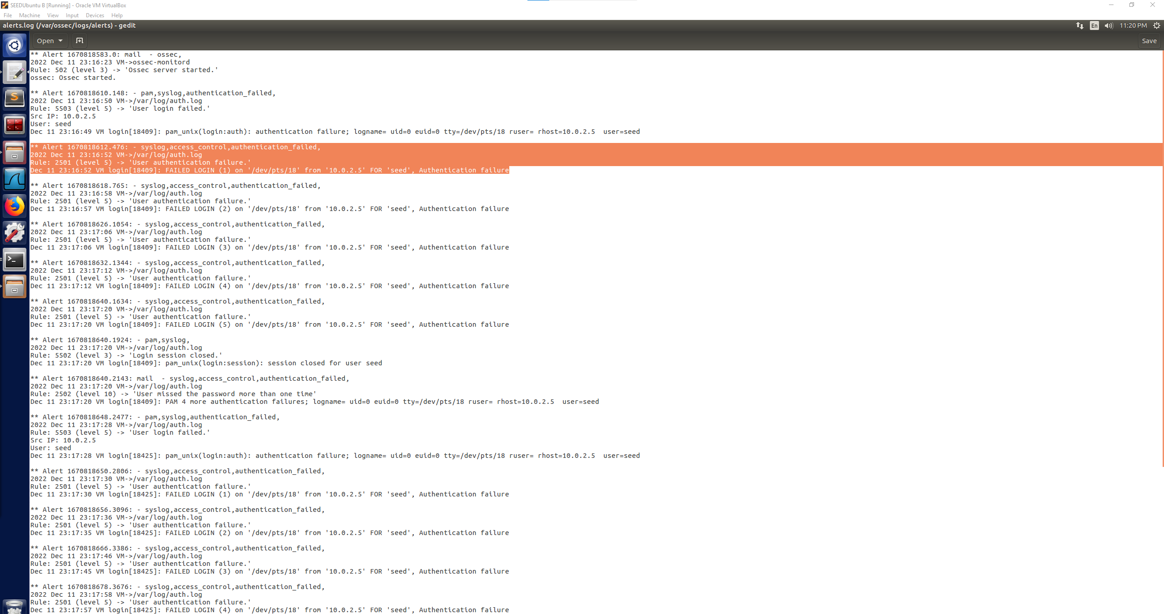

After the alerts for each individual attempt there is also a log of Rule 40111 which is “Multiple authentication failures” which lists all of the attempts, from what IP address, and for what user they were trying to access. This compiles the attempts and would be a good indication of a brute password guessing attempt.

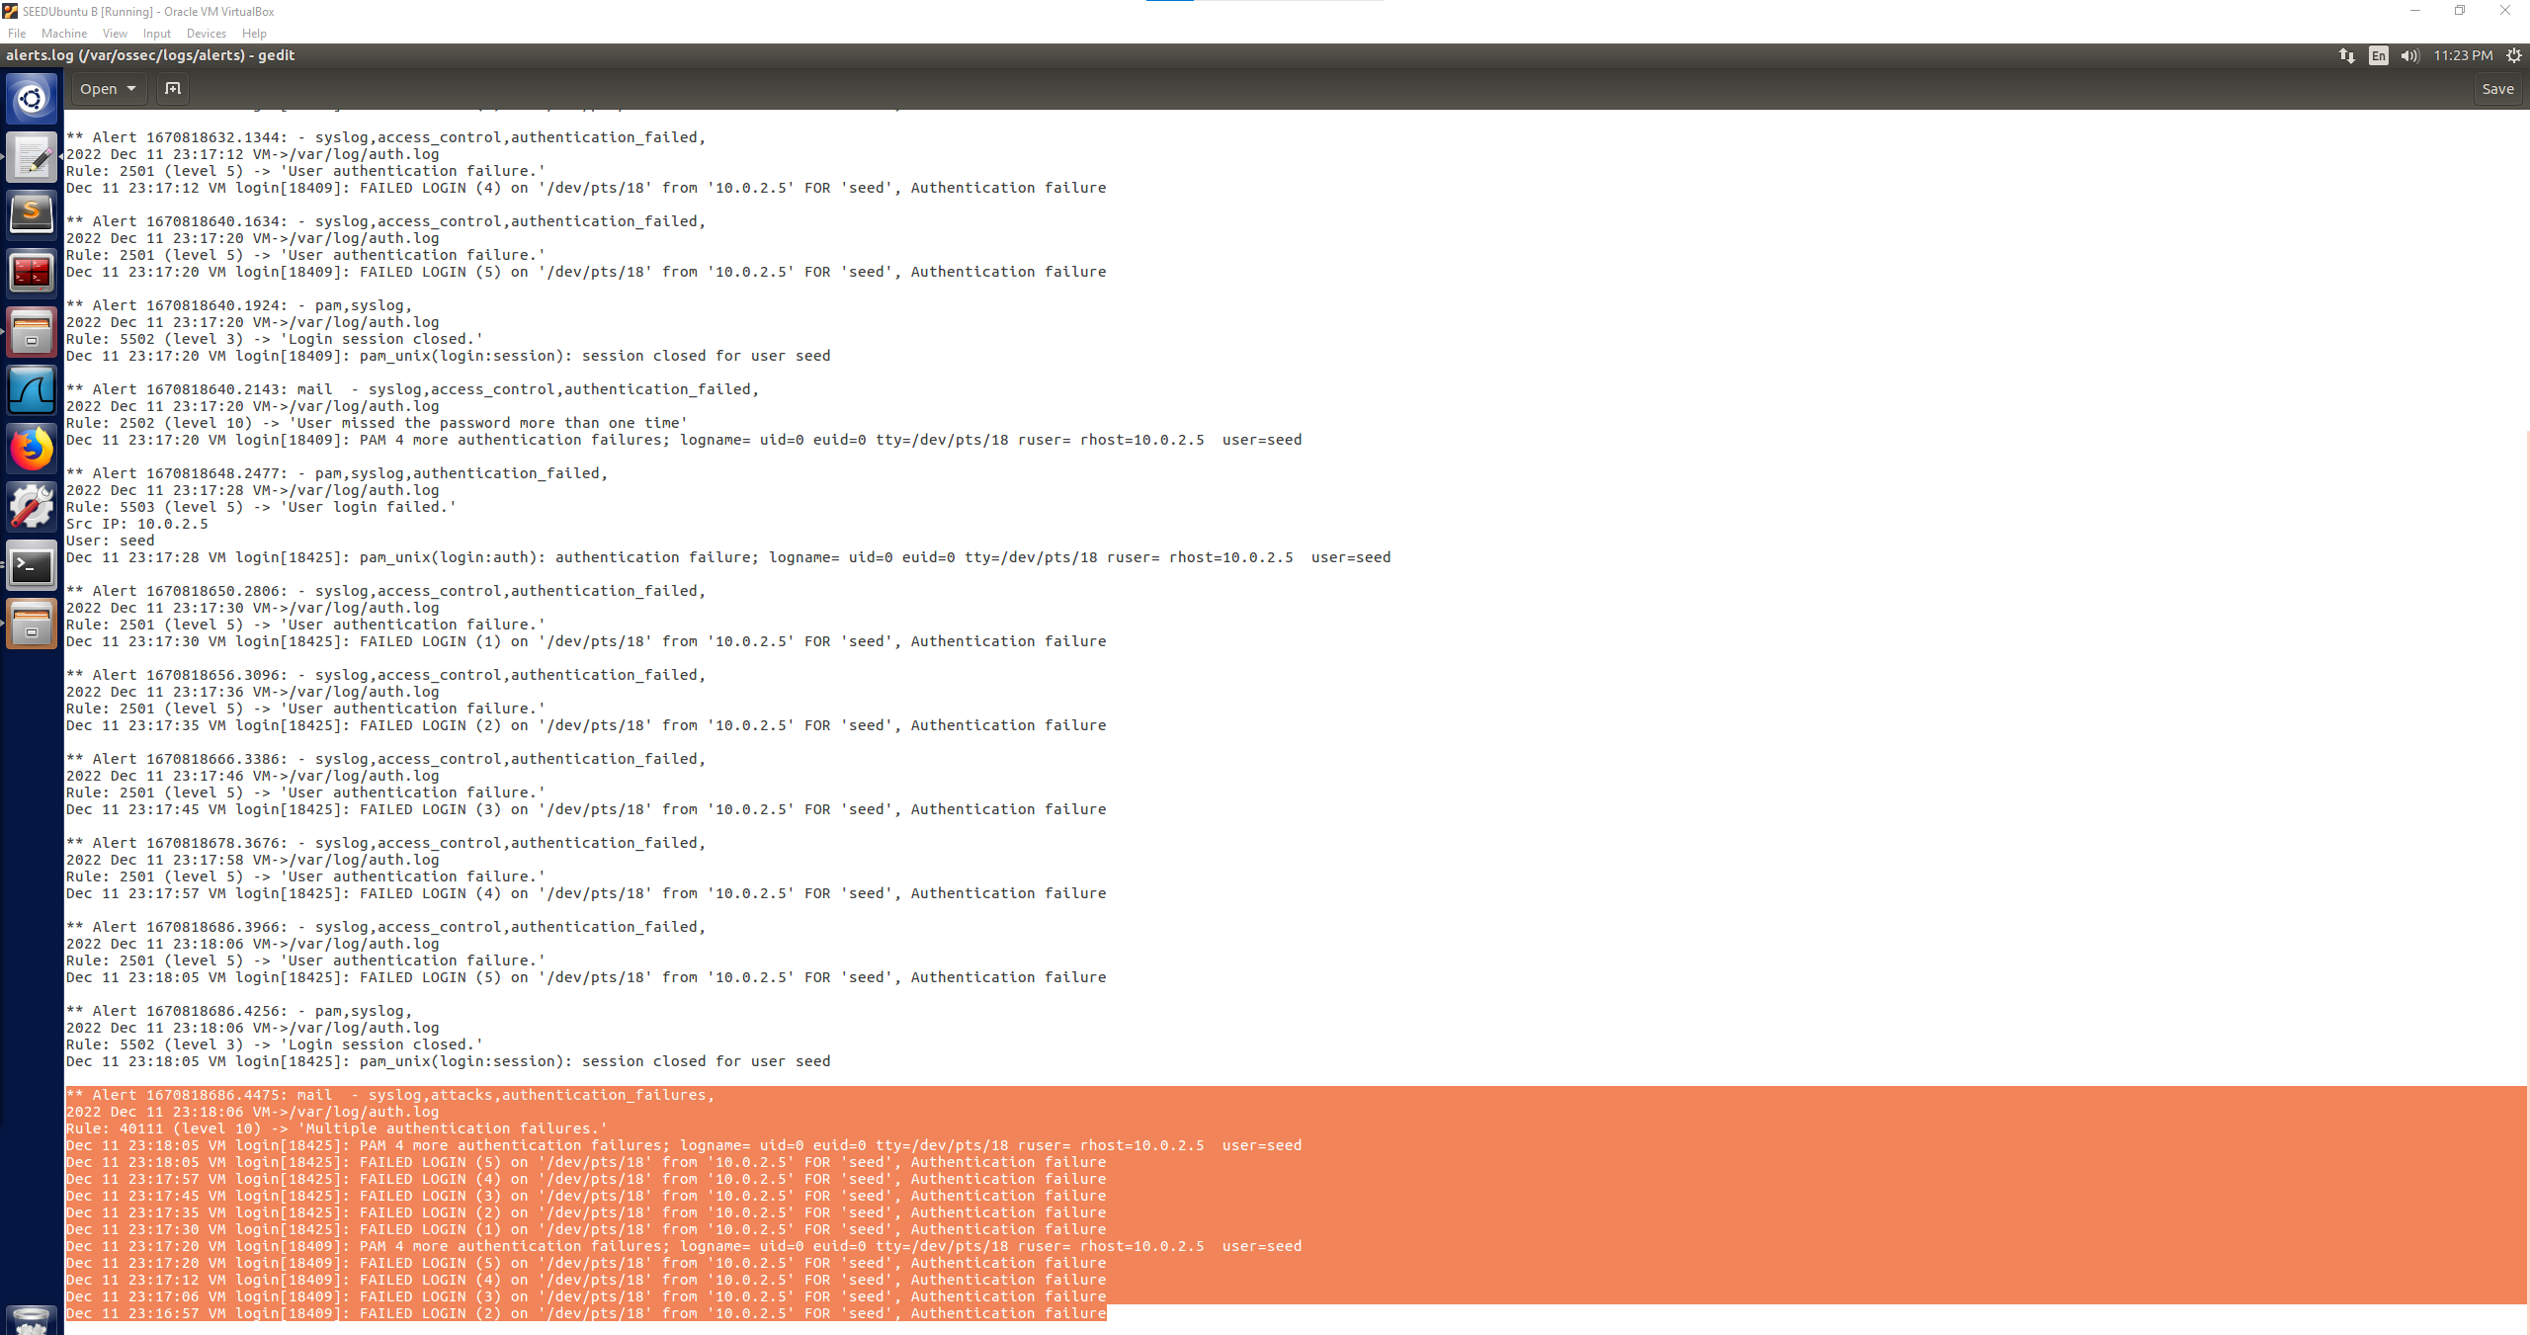

Next up was browsing the https and http websites. In the log file I did not see any alerts come up from the https browsing or the http browsing, I was not sure if this was an issue where nothing was being logged due to an error with the browsing or OSSEC not running, but after a second and third attempt of browsing the same websites and clicking on a few more links on the websites themselves there still was no updated information in the alerts.log file. The reasons for this that I can think of would be that there were no level 3 or higher alerts coming from the http or https websites, maybe the alerts would have been triggered at level 1 or 2 so they are not showing up. Or it is also possible that there are just simply no alerts being detected by OSSEC from the websites either due to configuration of OSSEC or that there is no malicious intent coming from the websites to be alerted to. Highlighted below is the second and third attempt of re-starting OSSEC and browsing through the websites to see if there was an issue the first try.

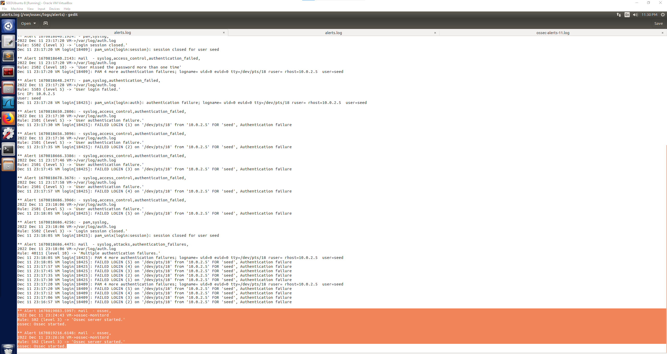

Next was the nmap port scan while OSSEC was running. Looking at the log file there was a new addition of a level 3 alert Rule 11401 listed as a “FTP session opened”. The source IP is also shown here from the VM that ran the nmap scan on the OSSEC VM, from the logged information that is the only item that I can directly attribute to the port scanning attack is that the source of the attack was 10.0.2.5 and that it was a connection attempt.

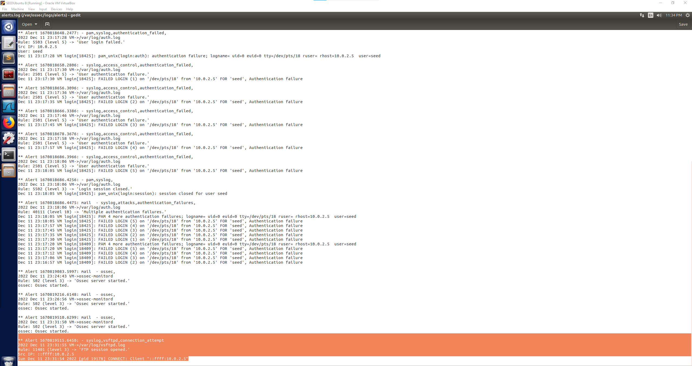

Next was the SYN Flood attack, to ensure that the attack was successful while OSSEC was running I also had Wireshark open as shown below to see that the SYN Flood attack was successful coming from spoofed IP address to port 80.

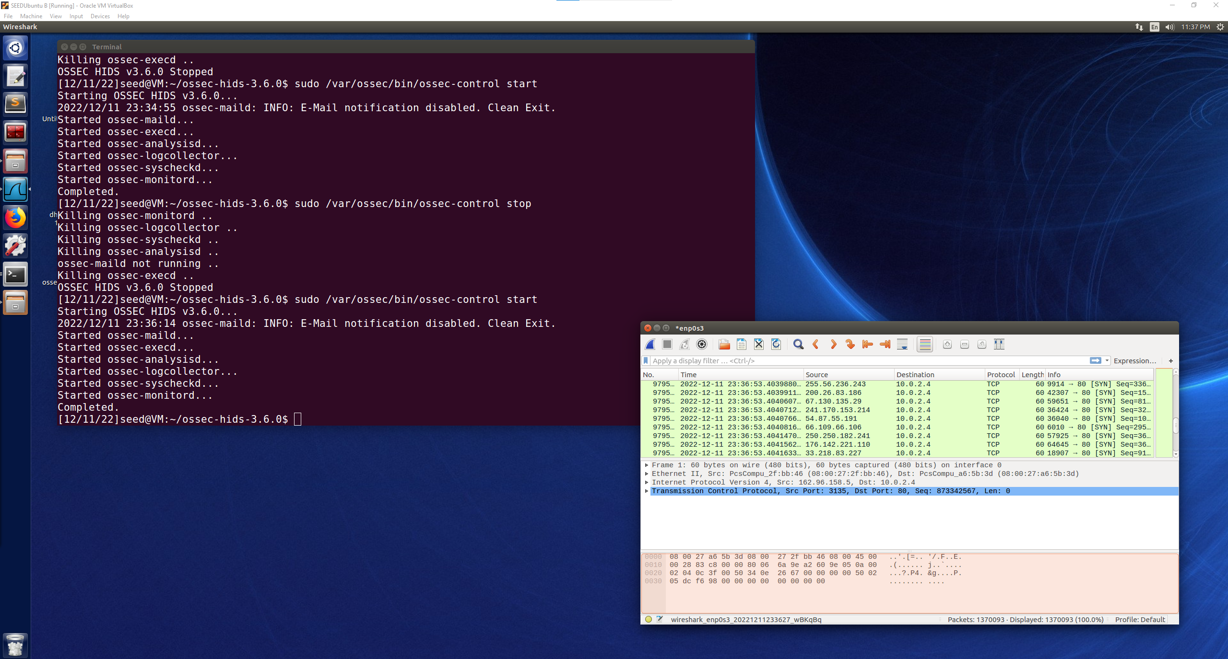

In the alerts.log file the only new entry that I found was that of a level 8 alert with Rule 5104 labeled as “Interface entered in promiscuous(sniffing) mode”. This alert I think would be attributed to the Wireshark program being opened and sniffing on enp0s3, which is a good bit of knowledge because the log would show if there was a sniffing program open on the user’s system that the user may not know about in the event that there was an undetected intrusion, and an attacker was using this system to sniff packets on the subnet. Other than that, there was no additional alert showing that a SYN Flood attack was taking place, which Wireshark confirms that the attack was successful. I found it interesting that the SYN Flood was not detected, but that the Wireshark sniffing on enp0s3 was alerted at a very high level.

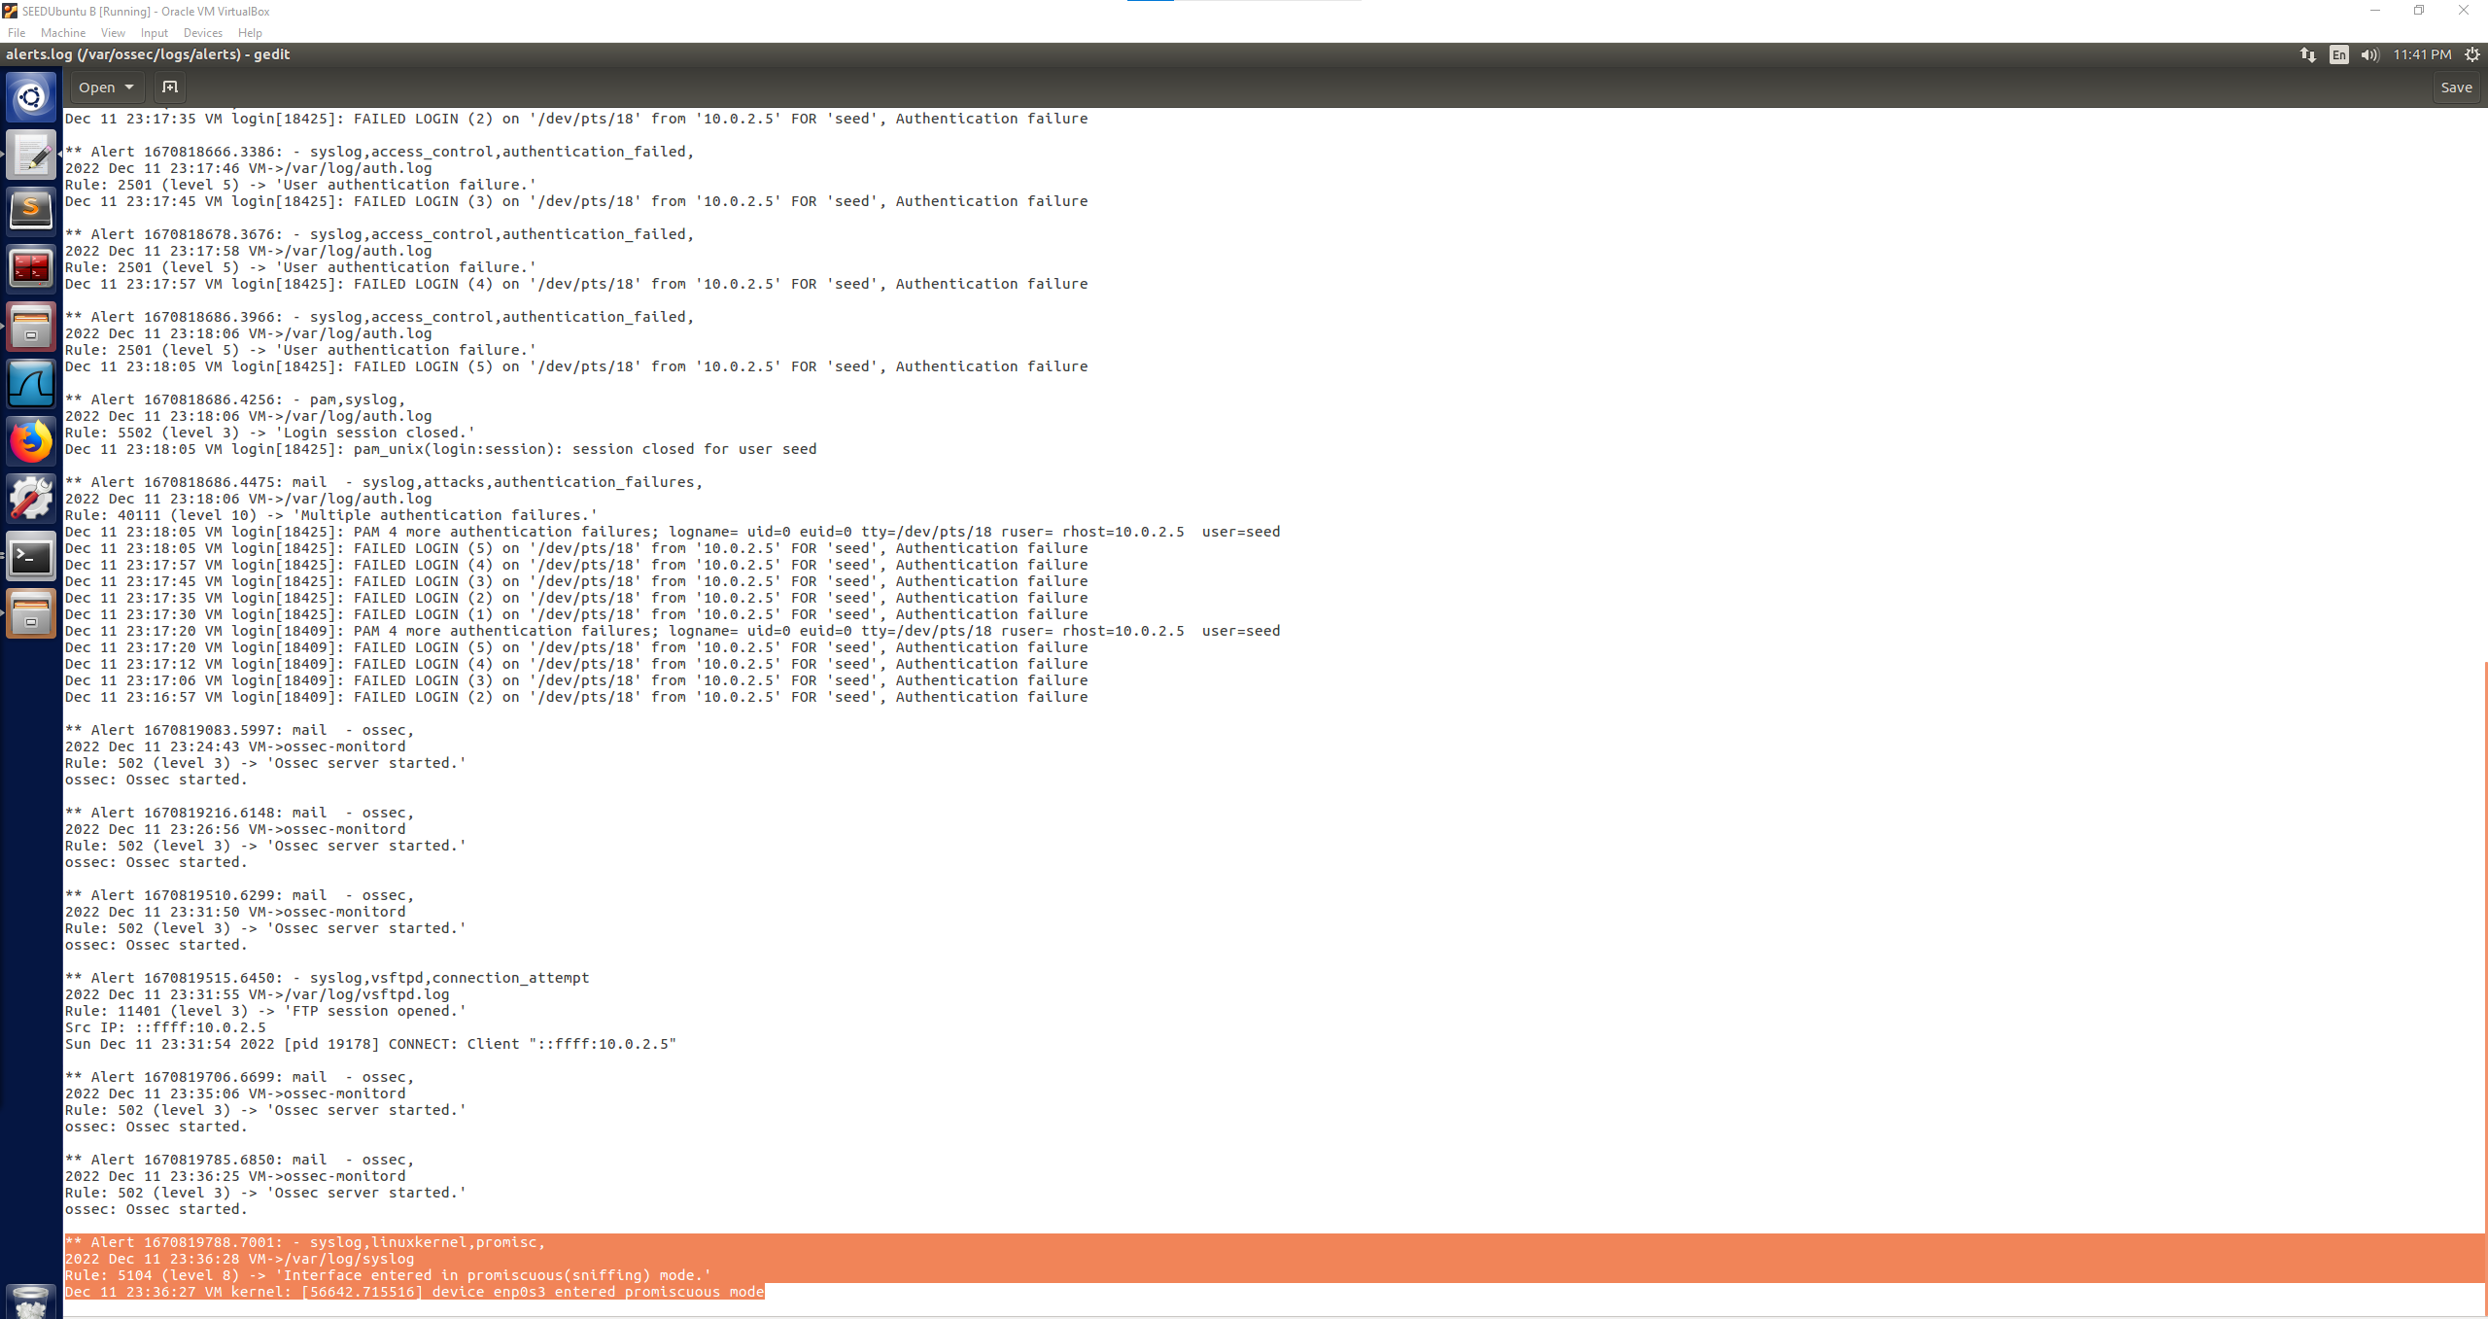

The third attack was a TCP reset attack on the OSSEC VM’s telnet connection to 10.0.2.7, as seen below the attack was successful in closing the OSSEC VM’s telnet connection.

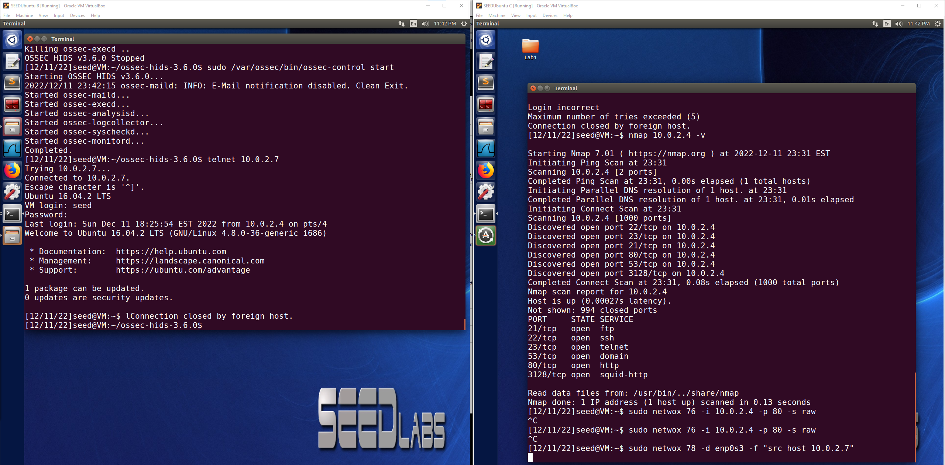

It appears that this attack, although successful was also not captured as an alert by OSSEC. There are no new alerts located in the log since the Wireshark alert. I think that it is possible that this could be considered lower than a 3 in severity which would cause this type of attack to not be logged with the current configurations of OSSEC on this VM. TCP Reset closed the telnet connection of the victim to the server but did not inflict an attack like a denial of service, the user would be able to telnet again into the server unless a TCP Reset attack was still taking place. The TCP Reset attack was successful as seen above, but it is not located in the log. The image below shows that there are no new logged alert entries.

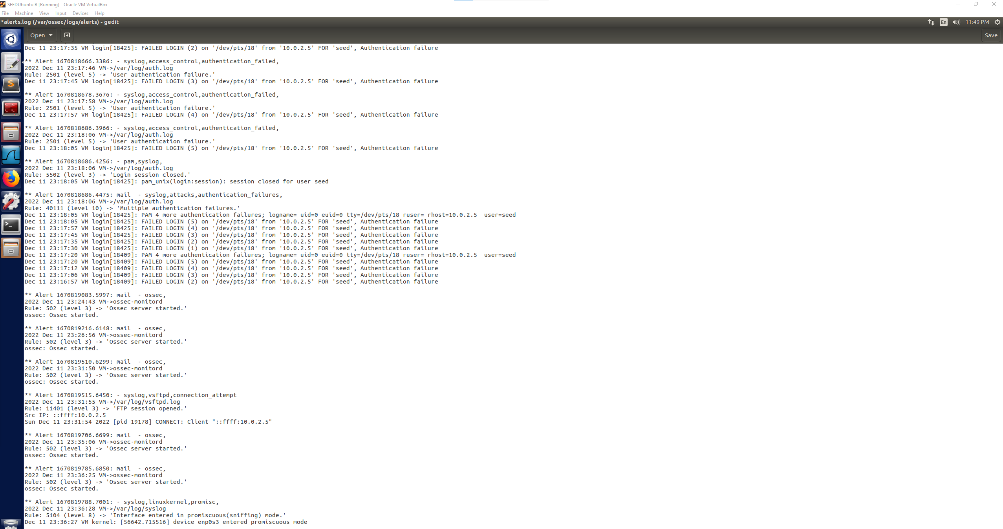

I had left OSSEC running previously while I was at my indoor soccer game and wanted to point out something interesting I had found in the alerts.log file that does not attribute to the attacks or browsing, but that was interesting. There were a series of Rule 516 alerts labeled as “System Audit event”. These pertained to the rootcheck part of OSSEC which I remembered seeing during the setup video as being included in our local installation of OSSEC on this VM. There were a variety of system audit categories shown such as Web exploits with possible compromises, Robust partition schemes with directories not being on its own partition and Disable standard boot services. In the image below there is also a highlighted alert that shows that IP Forwarding is enabled which would trace back to a previous lab where for purposes of testing we had enabled IP forwarding and OSSEC was able to determine that it was still enabled and could be a possible vulnerability leading to abnormal events.

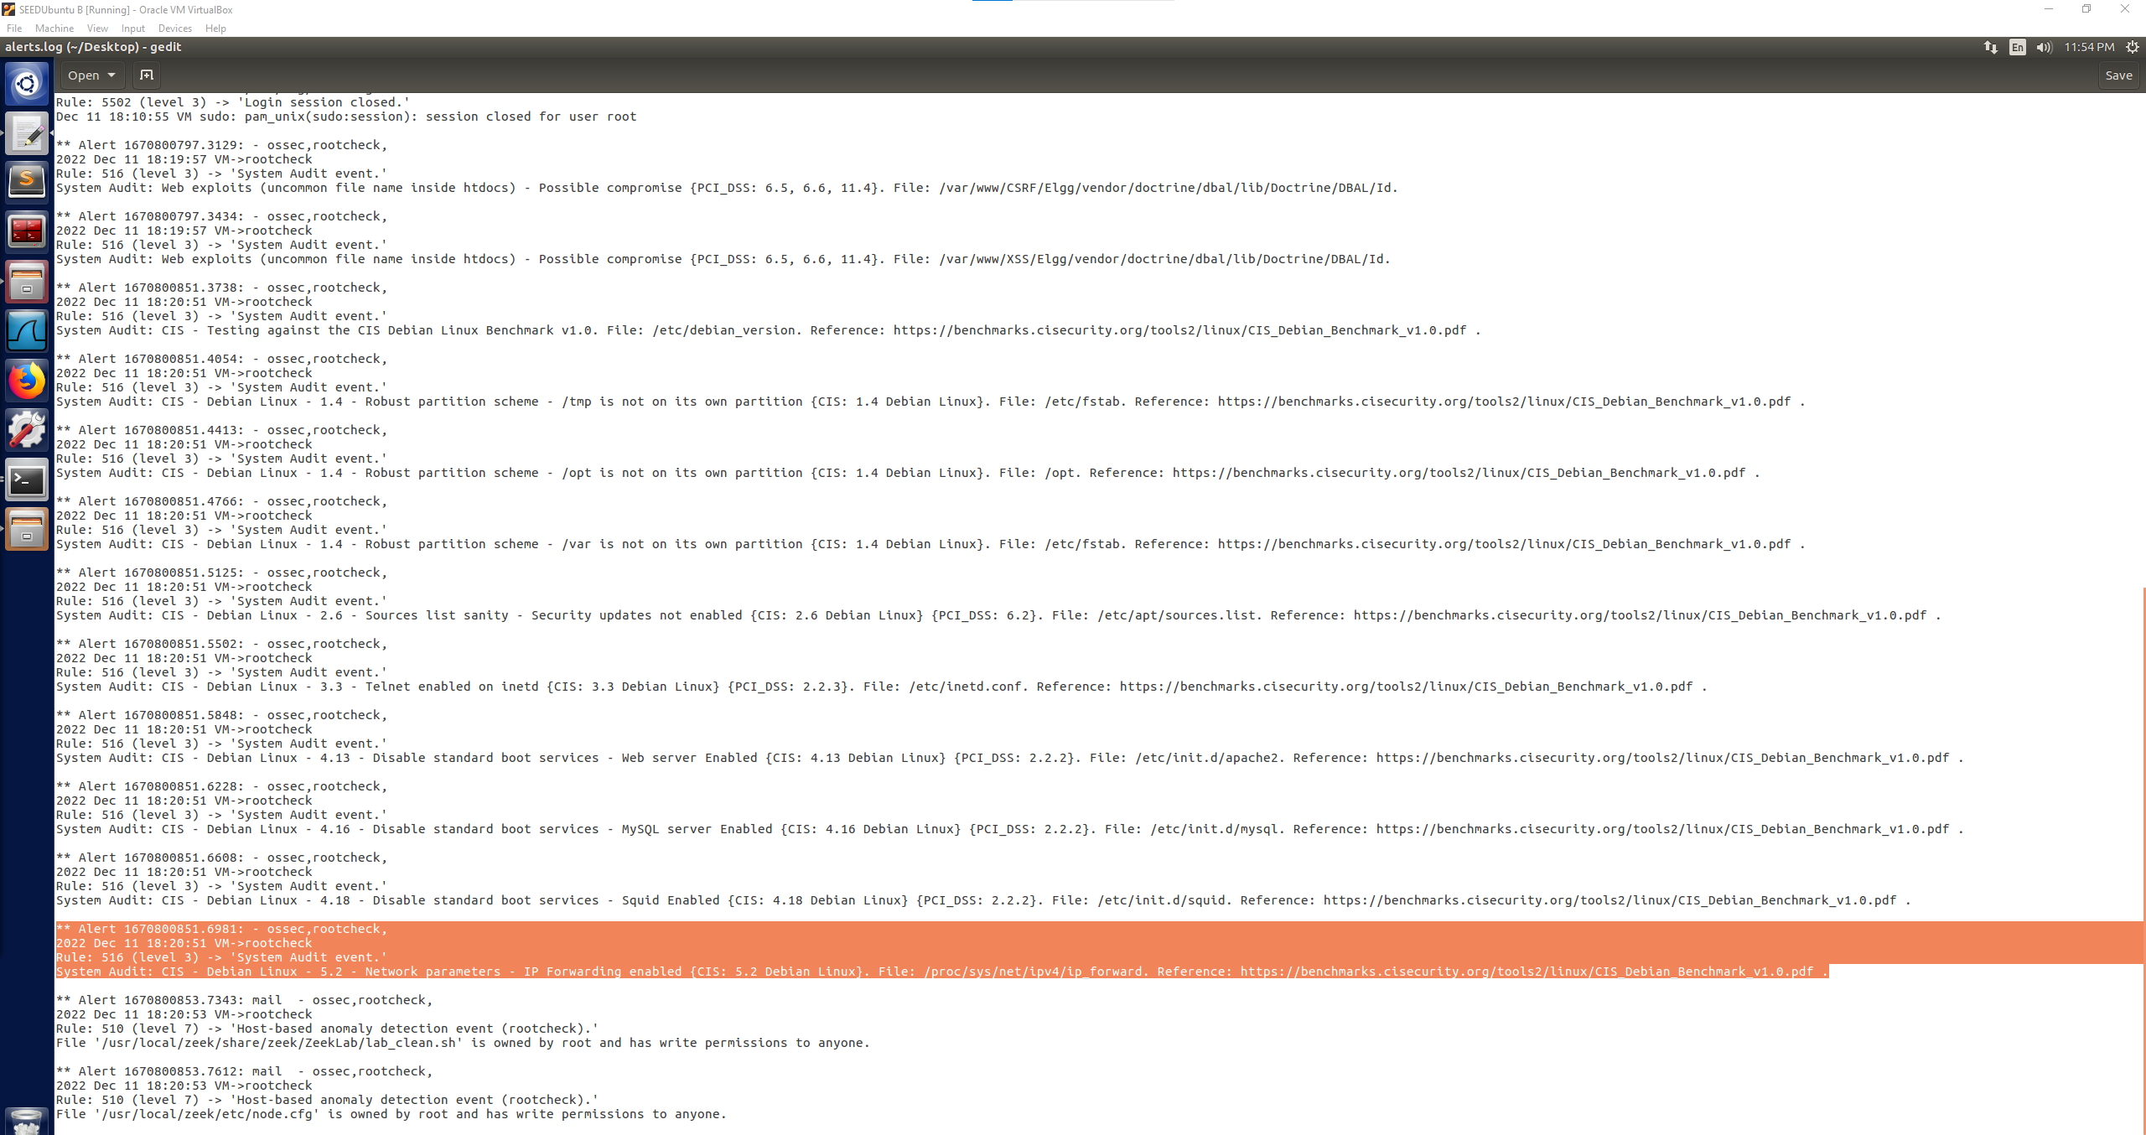

Also at the bottom of the above image there were two Rule 510 alerts labeled as “Host-based anomaly detection event” that pertained to two files in the zeek folder that is owned by root and has write permissions to anyone which OSSEC determined to be an anomaly and alerted it at a level 7.

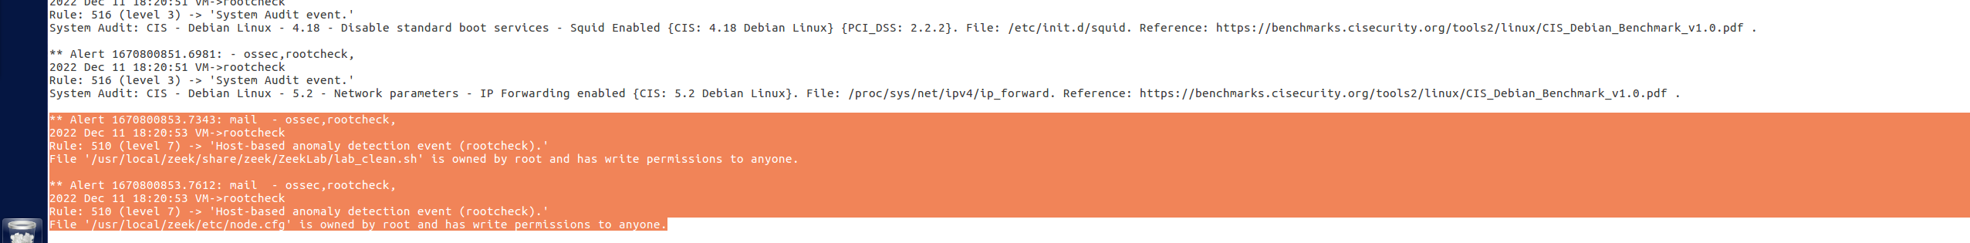

My takeaway from this lab with OSSEC is that OSSEC was able to provide a lot of information especially on the brute password attempts in a clean log setup. However, I was surprised that an attack such as a SYN Flood attack was not logged in the alerts.log file which could be due to a user error if it should’ve been logged but I was able to determine that OSSEC was running, and that the SYN Flood attack was successful through the use of Wireshark. This also lead to a new discovery that Wireshark sniffing packets was detected and alerted through OSSEC which has its own use to know that a sniffing program was running. It was also interesting to see what the rootcheck part of OSSEC had detected and alerted about such as the IP Forwarding still being enabled on this VM and highlighting that as a possible vulnerability. I think that it would be interesting to learn more about the capabilities of OSSEC such as what level would be associated with specific more severe attacks and if OSSEC would be able to detect and log them.